Using IF statements to create new variables
When conducting analysis, very often you need to create some new variables by grouping categories of an existing variable. In Excel, you can use IF statements to create new variables. Below is the syntax to show you how IF statements can be used to create two new variables. The two new variables are:
- “Age_70orAbove” (grouping all patients in the dataset into 2 groups, the “70 or above” group, and the “Less than 70” group)
- “Age_Grp” (grouping patients into 10 years age groups)
Note: In the UTS Hospital Data, Age is in column G
- To create variable “Age_70orAbove”
  - Place the cursor on Cell BI1 (the first cell of Column BI – if you have not made changes to the data file, BI is an empty column in the dataset, and the variable “Age” is in column G), type in “Age_70orAbove”
  - Move the cursor to Cell BI2 and type the following formula into the formula bar.
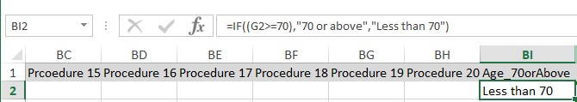

c.

Click on
when finish
d. Copy and paste the formula is Cell BI2 to the end

- To create variable “Age_Grp”
  - Place the cursor on Cell BJ1, type in the variable name “Age_Grp”
  - Place the cursor into Cell BJ2, and type the following formula into the formula bar
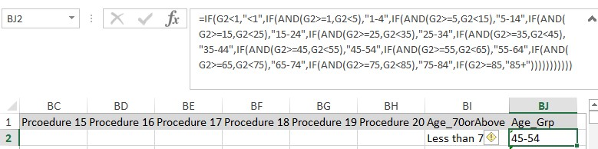

c.

Click on
when finish
d. Copy and paste the formula is Cell BJ2 to the end of the column

You can apply the same logical to create other variables that are needed for your assessment.
- The following exercises are related to the variables “LOS” and “age”.
  - Create a new variable calls “Age_Grp” which group patients into 10 years age group
  - Create a pivot table that gives you the mean “LOS” for each age group
  - Create a chart/figure which best present the results
  - Copy and paste the table and chart to a word document
  - Format the table and chart to appropriate health report format with appropriate table/figure numbers and description

